OSCN LAB – 4
Name: SYEDA FARHATH UMAMA
HALL TICKET NO.: 2503B05143

PROGRAM 4 – To implement Error Detection using Cyclic Redundancy Check.
TASK 1 : A bit stream 1101011011 is transmitted using the standard CRC method. The generator polynomial is x 4 +x+1. What is the actual bit string Transmitted.
TASK 2 : A bit stream 10011101 is transmitted using the standard CRC method. The generator polynomial is x 3 +1. What is the actual bit string transmitted. Suppose the third bit from the left is inverted during transmission. How will the receiver detect this error.
__________________________________________________________________
TASK 1 CODE:

//LAB 4.1
//Data =1101011011
// Generator Polynomial is x 4 +x+1.

#include <bits/stdc++.h>
using namespace std;
// Performs bitwise XOR between two binary strings (a and b)
string findXor(string a, string b) {
int n = b.length();
string result = "";

// Compare each bit (skip first bit as per CRC standard)
for (int i = 1; i < n; i++) {
if (a[i] == b[i])
result += "0";
else
result += "1";
}
return result;
}

// Performs Modulo-2 division (CRC division algorithm)
string mod2div(string dividend, string divisor) {
int n = dividend.length();
int pick = divisor.length();
string tmp = dividend.substr(0, pick); // Initial window

while (pick < n) {
if (tmp[0] == '1')
// XOR with divisor and bring down next bit
tmp = findXor(divisor, tmp) + dividend[pick];
else
// XOR with zeros and bring down next bit
tmp = findXor(string(pick, '0'), tmp) + dividend[pick];
pick++;
}

// Final XOR step
if (tmp[0] == '1')
tmp = findXor(divisor, tmp);
else
tmp = findXor(string(pick, '0'), tmp);

return tmp;
}

// Appends CRC remainder to the original data
string encodeData(string data, string key) {
int n = key.length();
string paddedData = data + string(n - 1, '0'); // Append n-1 zeros
string remainder = mod2div(paddedData, key);
return data + remainder; // Return data + CRC
}

// Checks if received data has errors (remainder = 0)
int receiver(string code, string key) {
string remainder = mod2div(code, key);
return (remainder.find('1') == string::npos) ? 1 : 0;
}

int main() {
string data = "1101011011";
string key = "10011";

cout << "Sender Side" << endl;
cout << "Data: " << data << endl;
cout << "Key: " << key << endl;
string code = encodeData(data, key);
cout << "Actual Bit Dtring Transmitted: " << code << endl << endl;

cout << "Receiver Side" << endl;
if (receiver(code, key))
cout << "Data is correct (No errors detected)" << endl;
else
cout << "Data is incorrect (Error detected)" << endl;

return 0;
}
TASK 1 OUTPUT: 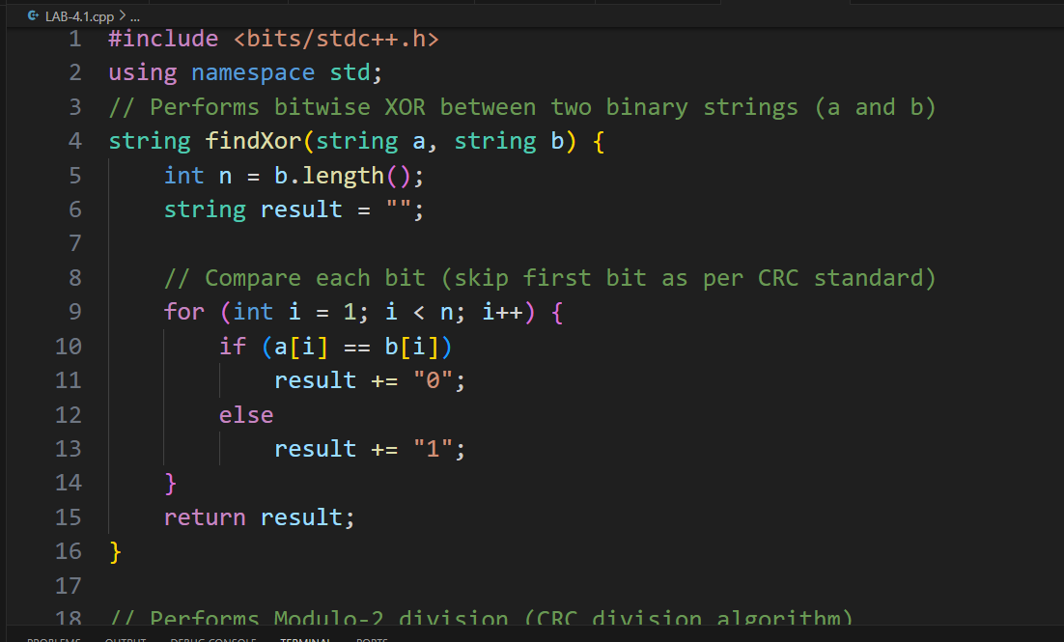
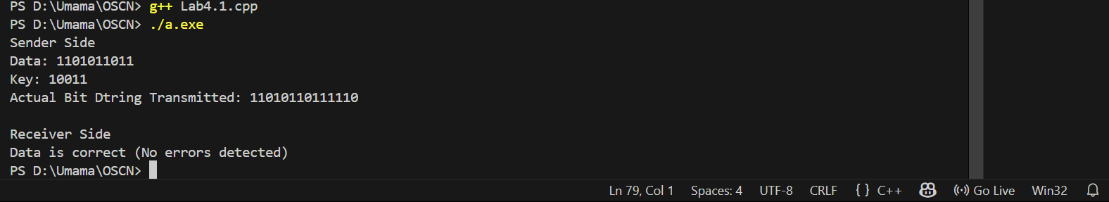

TASK 2 CODE:

//LAB 4.2
//Data (bit stream) = 10011101
//Generator Polynomial = x 3 +1

#include <iostream>
#include <string>
#include <algorithm>
using namespace std;
// XOR two bit-strings of length m, placing result into the dividend starting at pos
void doXor(string &dividend, const string &divisor, int pos) {
for (int i = 0; i < (int)divisor.size(); ++i) {
dividend[pos + i] = (dividend[pos + i] == divisor[i]) ? '0' : '1';
}
}
// perform binary division (mod-2) and return remainder of length (keyLen-1)
string mod2div(string dividend, const string &divisor) {
int n = divisor.size();
int len = dividend.size();
for (int i = 0; i <= len - n; ++i) {
if (dividend[i] == '1') {
doXor(dividend, divisor, i);
}
}
// remainder is the last (n-1) bits
return dividend.substr(len - (n - 1));
}
int main() {
string data = "10011101";
string key = "1001"; // x^3 + 1
// Append (n-1) zeros to data
string app = data + string(key.size() - 1, '0');
// Calculate remainder
string remainder = mod2div(app, key);
// Final codeword = data + remainder
string codeword = data + remainder;
cout << "Data : " << data << endl;
cout << "Generator : " << key << endl;
cout << "Remainder : " << remainder << endl;
cout << "Codeword : " << codeword << endl << endl;
// --- Simulate error: invert the 3rd bit from the left (index 2, 0-based)
string received = codeword;
int flipIndex = 2; // third bit from left
received[flipIndex] = (received[flipIndex] == '1') ? '0' : '1';
cout << "Received (3rd bit flipped): " << received << endl;
// Receiver divides received word by generator. If remainder != 0 => error detected
string rcv_rem = mod2div(received, key);
cout << "Remainder on receiver side: " << rcv_rem << endl;
if (rcv_rem.find('1') != string::npos) {
cout << "Result: ERROR DETECTED (non-zero remainder)" << endl;
} else {
cout << "Result: No error (remainder zero)" << endl;
}

return 0;
}

TASK 2 OUTPUT:





